DATA

WAREHOUSING

PROJECT

Group Members:

Name &

Surname: Boitumelo

Mathabathe

StudentNo:578041

Name &

Surname: Mokgadi

Comfort

Hamese

Student No:577358



Contents

PROJECT SCOPE & OBJECTIVES: 2

USER INQUIRIES 3

INFORMATION PACKAGES 4

Student Performance Package 4

Teaching Staff Analysis Package 4

High School Comparison Package 4

Exam Question Analysis Package 4

Exam Comparison Package 4

Exam Success Package 4

Lecture Attendance Package 5

Business Fact Tables 5

Exam Fact Table 5

Assessment Fact Table 5

Attendance Fact Table 5

Course Fact Table 5

Student Fact Table 5

Dimension Tables 6

Student Dimension 6

Course Dimension 6

Assessment Dimension 6

Question Dimension 6

Time Dimension 6

Staff Dimension 6

Entity relationship diagram 7

STAR SCHEMA 8

Examples of Data in the tables 9

DATA WAREHOUSE 13

Conclusion 14

# PROJECT SCOPE & OBJECTIVES:

The objective of this project is to create and implement a data warehouse for Belgium Campus University of Computing with the aim of monitoring and evaluating student performance across various courses. The data warehouse will be structured to meet the following business needs:

1. Track students' progress in multiple courses, encompassing mid-term exams, lecture attendance, and weekly assessments.
2. Compile comprehensive score summaries, including mid-term assessments, lecture attendance, and weekly evaluations, at the conclusion of each semester.
3. Identify students exceeding a predefined score threshold, making them eligible to participate in the final exam.
4. Students achieving satisfactory scores on the final exam will be considered as passing.
5. Offer information to teaching staff for analyzing their lecture delivery and exam design processes, aiding in the identification and resolution of potential issues.
6. Examine responses to different question types in mid-term and final exams to pinpoint common mistakes and areas requiring more in-depth explanations.
7. Determine the number of students passing an exam by a specified date in relation to their performance in course assessments and lecture attendance.
8. Calculate the percentage of students passing the exam based on their mid-term performances.
9. Ascertain the percentage of students eligible to take the final exam based on their term assessment scores.
10. Contrast student grades with success in term assessments and lecture attendance.
11. Compare average grades from distinct written exams within the same course.
12. Identify correlations between exam success and the types of high schools attended by students.
13. Assess the accuracy of answers to questions on exams.
14. Identify questions with the majority of correct answers and those presenting the most challenges for students.

# USER INQUIRIES

Users have the option to make specific requests tailored to their requirements. In this instance, the user seeks to monitor and analyze the academic performance of students enrolled in various courses at Belgium Campus University of Computing.

Tracing students' performance in multiple courses at Belgium Campus University of Computing involves systematically gathering and examining data related to individual students' academic advancements across diverse subjects. This data encompasses grades, exam results, attendance records, and other pertinent information.

The primary aim of tracing students' performance is to detect patterns and trends in their academic journey, utilizing this knowledge to foster student success and retention. Through continuous monitoring, educators and administrators can identify students who may be at risk of falling behind or disengaging and can provide targeted assistance and resources to keep them on track.

Beyond supporting individual students, tracing performance across various courses offers valuable insights into the effectiveness of the university's curriculum, teaching methodologies, and support services. By scrutinizing data spanning multiple courses, educators can pinpoint areas where students might be encountering challenges, enabling adjustments to enhance the overall educational experience.

To effectively trace students' performance across multiple courses at Belgium Campus University of Computing, implementing a data tracking system or data warehouse may be necessary. This system should consolidate data from various sources into a unified view, maintaining a consistent and standardized format. User-friendly interfaces should also be provided for educators and administrators to access and analyze the data.

In summary, the process of tracing students' performance across multiple courses is crucial for educational institutions. It ensures students receive the necessary support for success and provides valuable insights into the overall efficacy of the educational program.

# INFORMATION PACKAGES

## Student Performance Package

This package encompasses data pertaining to student academic performance, covering exam scores, course assessments, attendance records, and final grades. The Exam Results fact table is central to this package, featuring dimensions like Date, Course, Student, Exam Type, and Assessment Type.

## Teaching Staff Analysis Package

Designed to aid teaching staff in evaluating their lecturing methods, exam design strategies, and potential issues, this package employs the Teaching Analysis fact table. Key dimensions include Date, Course, Teaching Staff, Exam Type, Question Type, and Student Type.

## High School Comparison Package

This package facilitates the comparison of success rates among students from different high school backgrounds. The High School Comparison fact table serves as the foundation, incorporating dimensions such as Date, Course, Student, High School Type, and Exam Type.

## Exam Question Analysis Package

Focusing on exam question analysis, this package provides insights into answer correctness, difficulty levels of questions, and identifies the easiest and most challenging questions. The Exam Question Analysis fact table is utilized, with dimensions like Date, Course, Exam Type, Question Type, and Question Difficulty.

## Exam Comparison Package

Dedicated to comparing grades across various written exams within the same course, this package employs the Exam Comparison fact table. Dimensions include Date, Course, Student, Exam Type, and Assessment Type.

## Exam Success Package

This package offers information on student success rates in exams, encompassing the number of students passing exams by a specified date, the percentage passing based on mid-term exams, and the percentage eligible for the final exam based on term assessment scores. The Exam Success fact table is structured with dimensions such as Date, Course, Student, Exam Type, and Assessment Type.

## Lecture Attendance Package

Focusing on student attendance, this package includes details on the number of attended and missed lectures. The Lecture Attendance fact table is employed, featuring dimensions like Date, Course, Student, and Lecture Type.

# Business Fact Tables

## Exam Fact Table

This fact table consolidates information on exams undertaken by students, encompassing exam scores, dates, and types (mid-term, final). Dimensions linked to this fact table include student, course, and time.

## Assessment Fact Table

This fact table compiles information about assessments conducted throughout the semester, covering assessment scores, dates, and types (weekly, monthly). Dimensions associated with this fact table include student, course, and time.

## Attendance Fact Table

This fact table captures details about students' attendance in lectures, including dates and attendance types (mandatory, optional). Linked dimensions encompass student, course, and time.

## Course Fact Table

Containing information about the courses offered, this fact table includes course code, name, description, and credit hours. Dimensions connected to this fact table involve student and time.

## Student Fact Table

This fact table houses information about enrolled students, featuring student ID, name, email, phone number, and address. Dimensions associated with this fact table include course and time.

# Dimension Tables

## Student Dimension

This dimension table compiles details about individual students, encompassing their name, student ID, attended high school, enrolled program, and other pertinent demographic information.

## Course Dimension

This dimension table encompasses information about each course available at Belgium Campus, including the course name, code, associated program, and other relevant details.

## Assessment Dimension

Focused on various assessments taken by students, such as mid-term exams, final exams, lecture attendance, and weekly assessments, this dimension table assigns a unique ID to each assessment. It includes crucial details like the assessment date and maximum achievable score.

## Question Dimension

This dimension table provides information about individual questions within each assessment, featuring the question text, correct answer, and additional metadata like the question's topic or difficulty level.

## Time Dimension

Centralized around dates significant to the data warehouse, this dimension table includes dates when assessments occurred, courses were offered, or grades were finalized. It incorporates details such as the year, semester, week, and day associated with each date.

## Staff Dimension

This dimension table consolidates information about the teaching staff at Belgium Campus, covering their name, staff ID, department, and other relevant details.

# Entity relationship diagram

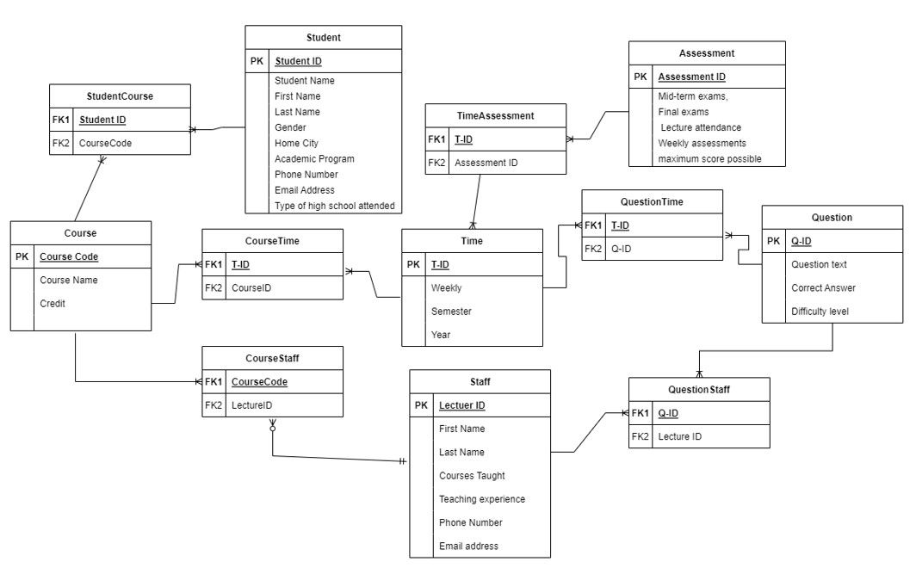

# STAR SCHEMA

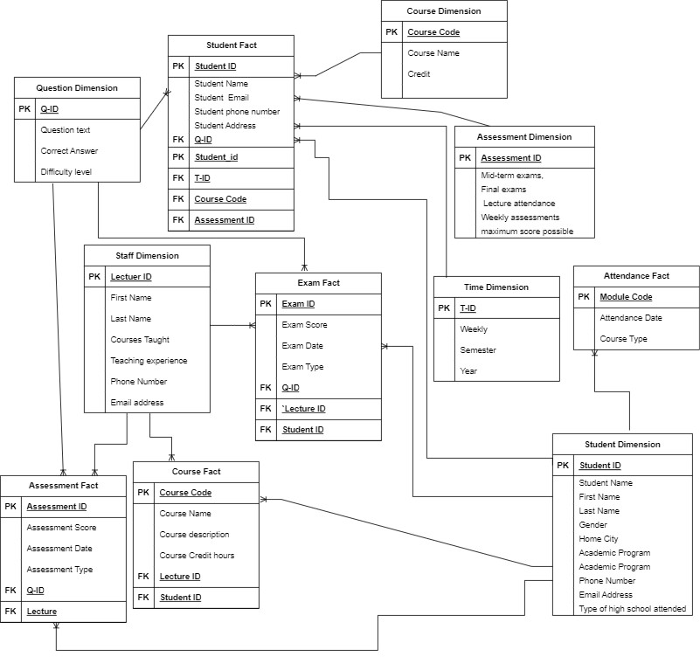

# Examples of Data in the tables

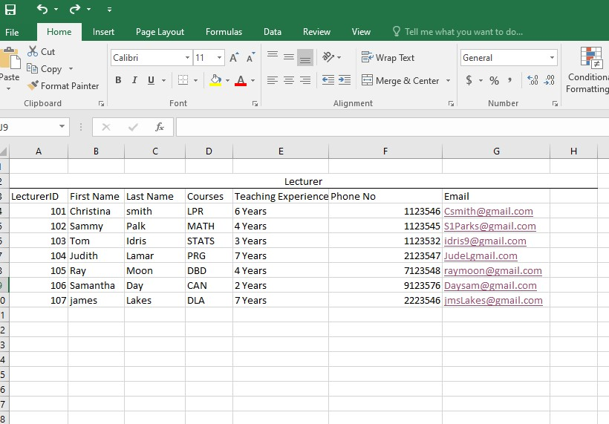

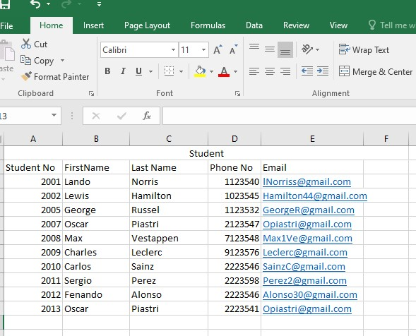

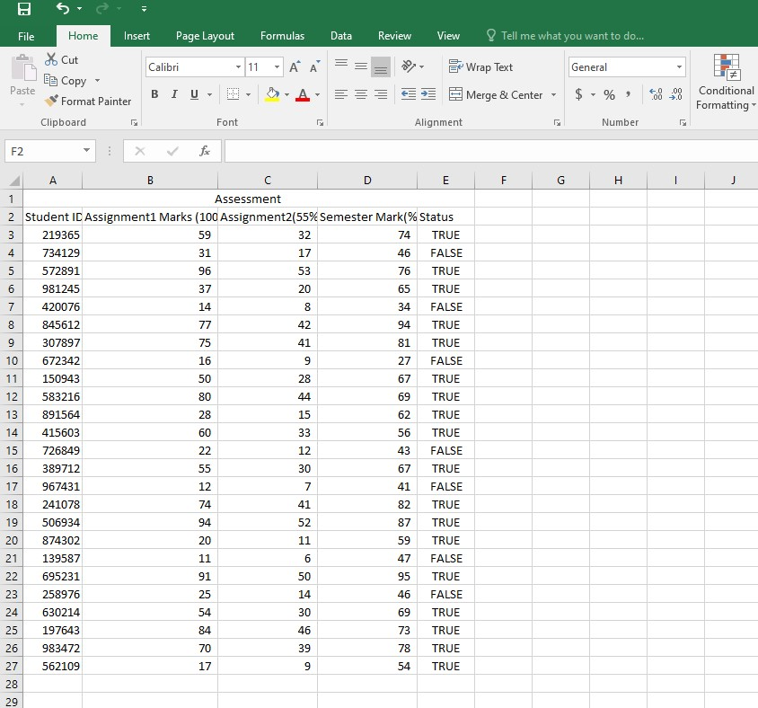

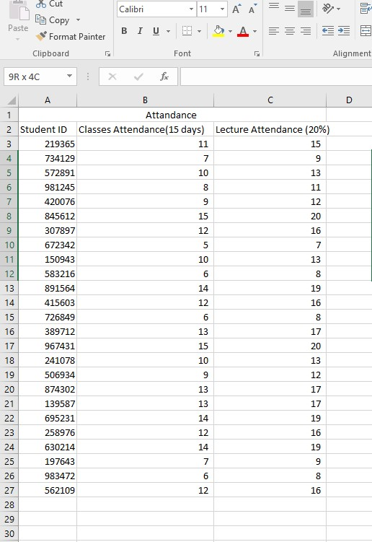

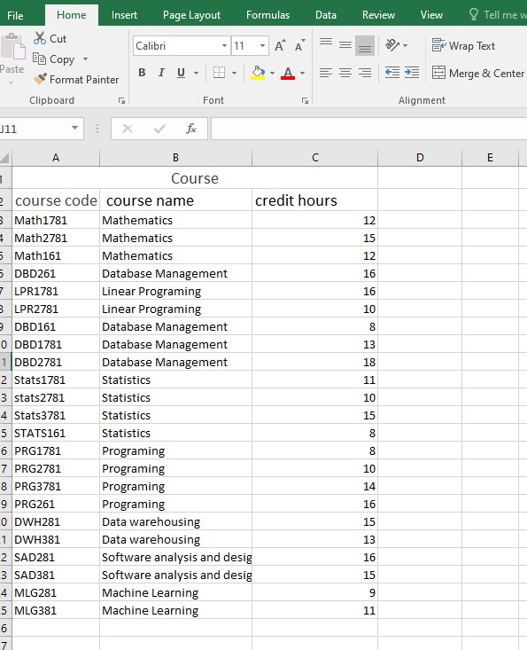

# DATA WAREHOUSE

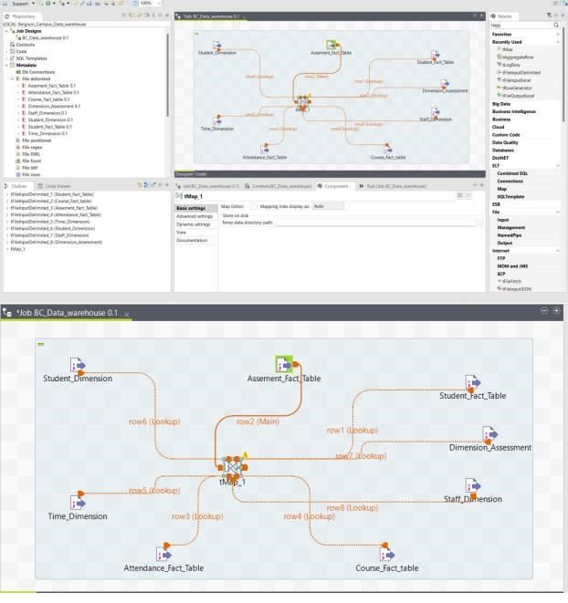

# Conclusion

In conclusion, the successful implementation of the data warehouse project for Belgium Campus University of Computing marks a significant achievement in enhancing educational practices. The project's focus on monitoring and evaluating student performance across various courses has been realized through a user-centric approach, emphasizing the importance of implementing a data tracking system. The designed Information Packages, Business Fact Tables, and Dimension Tables provide a versatile tool for informed decision-making. Visual representations, such as the Entity-Relationship Diagram and Star Schema, enhance data structure clarity. Examples of data showcase practical applications. The project not only meets its objectives but also sets the stage for ongoing refinements, promising valuable insights for optimizing teaching methods and supporting individual students.